

**The Complete Smith Chart**

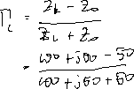

Black Magic Design



90

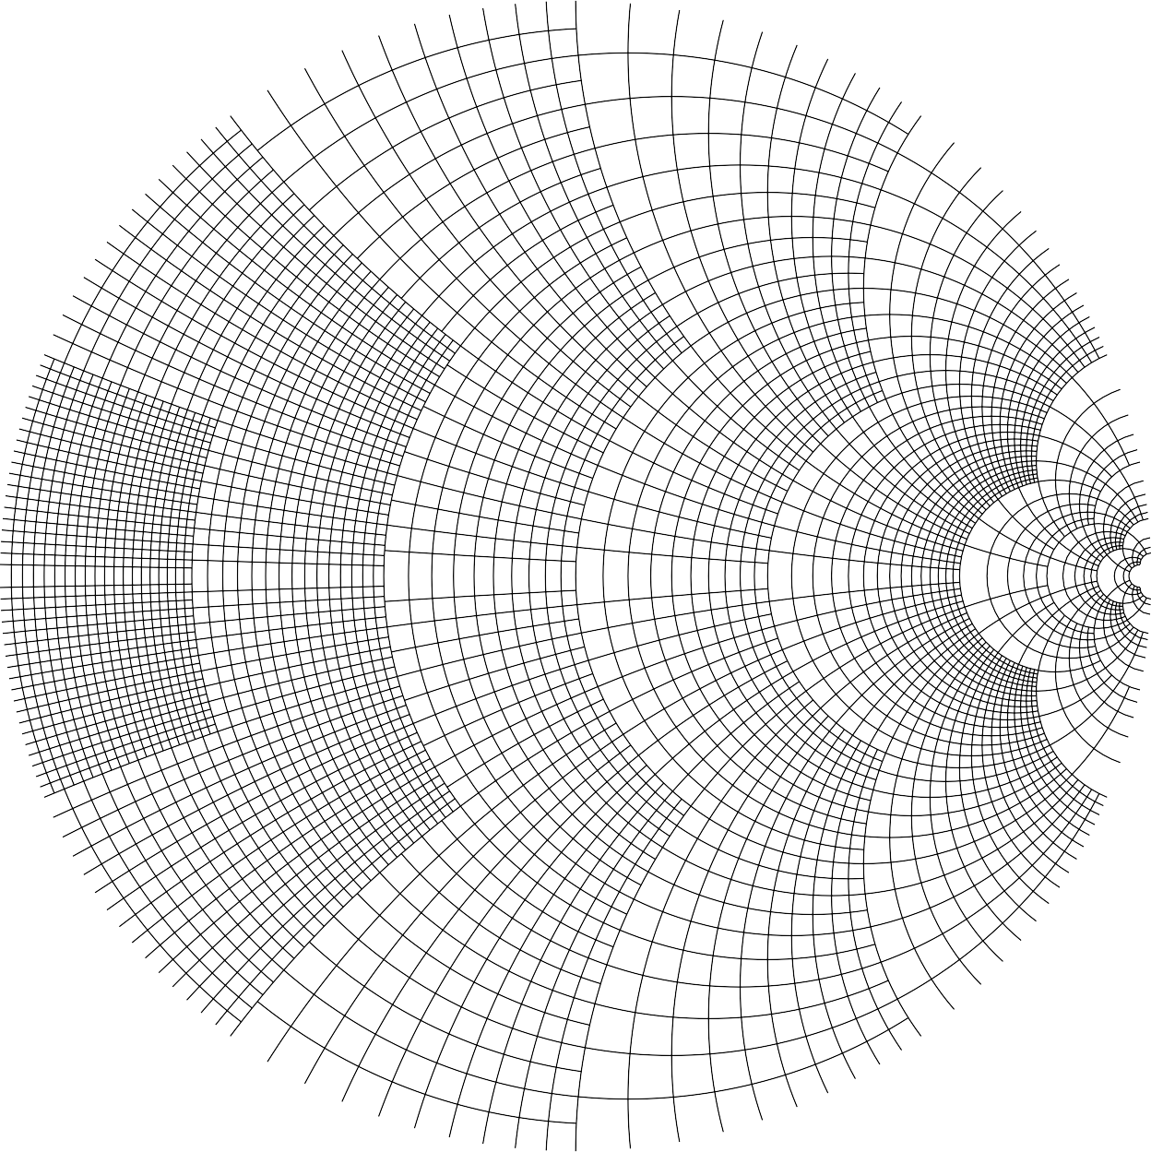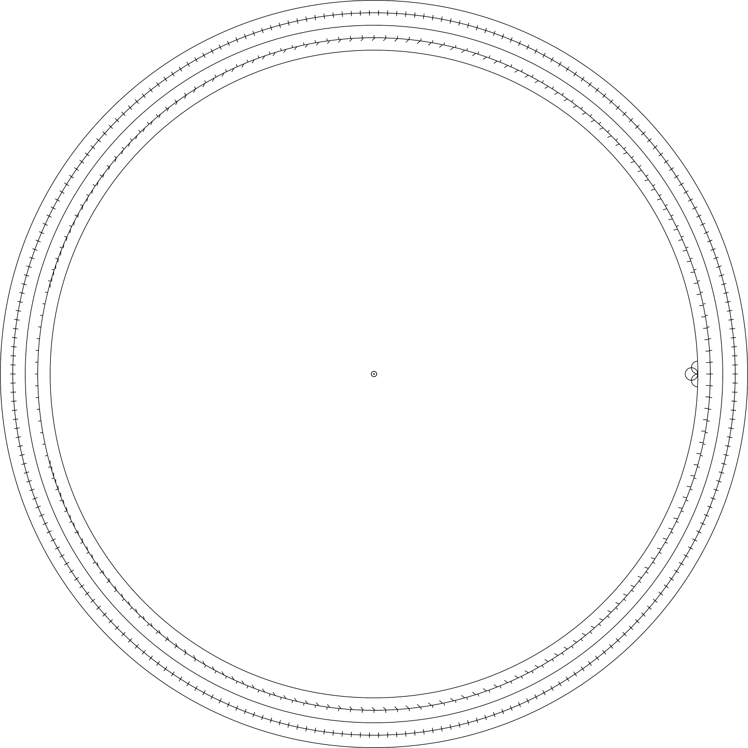

1.0

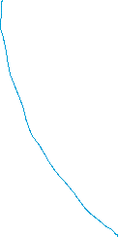

RESISTANCE COMPONENT (R/Zo), OR CONDUCTANCE COMPONENT (G/Yo)

0.25

0.25

COE

N CO

0.0

0.0

 180

-90

90

0.1

0.2

0.3

0.4

0.5

0.6

0.7

0.8

0.9

1.0

1.2

1.4

1.6

1.8

2.0

3.0

4.0

5.0

10

20

50

RADIALLY SCALED PARAMETERS

1.0

TOWARD LOAD —> <— TOWARD GENERATOR

100 40 20 10

5 4 3

2.5

2 1.8

1.6

1.4

1.2 1.1 1 15 10 7

5 4 3 2 1

 40 30

20 15

10 8

6 5 4 3 2

1 1 1

1.1 1.2 1.3 1.4 1.6 1.8 2 3 4 5 10 20 

0 1 2 3 4 5 6 7 8 9 10 12 14 20 30  0 0.1 0.2 0.4 0.6 0.8 1 1.5 2 3 4 5 6 10 15

1 0.9

1

0.8

0.9

0.7

0.6

0.8

0.5

0.7

0.4

0.6

0.3

0.5

0.2

0.4

0.1

0.3

0.05

0.2

0.01

0.1

0 0

0 1

CENTER

1.1 1.2 1.3 1.4 1.5 1.6 1.7 1.8 1.9 2 2.5 3 4 5 10 

0.99 0.95 0.9 0.8 0.7 0.6 0.5 0.4 0.3 0.2 0.1 0

0.0 0.1 0.2 0.3 0.4 0.5 0.6 0.7 0.8 0.9

ORIGIN

1 1.1 1.2 1.3 1.4 1.5 1.6 1.7 1.8 1.9 2

